Name
Course
Instructor
Date
Arts of Early Africa
The Connection of the Artistic Works in Djenne to The Current World
The artistic works that originate from Djenne in sub-Saharan are imposing. The sculptures are very vital, especially to historians and archeological researchers. The archeological evidence is found in few museums and archeological sites located in the unites states and west Africa. The ancient artistic work is essential to the current world simply because they paint pictures of past civilization that are crucial in narrating the rich African heritage that should be kept and told to future generations.
The artistically are connect with the present through history classes. Various history students learn about an ancient civilization that previously existed. Students will be more amused with sculptures that paint pictures of how those people look, lived, and their primary occupational affiliations" Africa and the Nok culture period" (Breunig 33). The artworks found in the museums and archeological sites help the students understand the past civilization better, thus making the materials relevant in the current era of human existence.
The materials connect to the present world through archaeologists and historical researchers. The artistic materials are often found in museums and archeology sites. Researchers nowadays tend to further their findings by studying those artifacts. Some go to the extent of excavating more materials that could give evidence of the past civilization. The archaeologists' aggressive concern and the will to discover more artistically remains to make the materials relevant to the current world.
The Uses of the Artistic Material to The Current World
The artistic material found in Djenne in West Africa is very vital in contemporary society. The materials are located in museums and different archaeological sites. The places often attract tourists and other groups of people, including learners and historical researchers. The institutions make good revenues when such individuals visit them, thus growing their economy “Stealing the rich African history” (Brodie 7). The materials can be bought by various interested persons for the purposed of the study. Researchers are the number one customers who get the material to take them to their laboratories and conduct their research works.
The artistic material is used to make films and documentaries. The materials are rich historical objects that can be documented in the various source may it be printed or filmed. Researchers often take pictures and film documentaries of such caliber for purposes of storing the information. Moreover, their research works are more presentable and eye-catching to their intended audience, making the artistic material even more precious. The images and documented films can be sold worldwide and help to market the rich African heritage that may have been forgotten for many years.
Request to Return the Artistically Work from Museums to Specific Nations
The materials that originated from Djenne carry with them a rich historical heritage. Unfortunately, the materials were sold to various European continents during the famous trans-Atlantic trade that was quite dominant in sub-Saharan Africa. The European nations valued those products and kept them in their museums for the purposed of artistic events. The materials, however, carry broad African history with them, which should not be sidelined.
The united states government in Boston discovered the artistic material among their museums. This was exciting news that excited archaeologists, especially in Nigeria, Africa. The information was posted on the internet; hence various historical researchers identified it and claimed it. The materials were said to be pillaged by the British army in the ninetieth century, and they wanted it back. Fortunately, their plight was heard, and their materials were given back to them. They were well preserved in their museums, and enormous citizens of Nigeria started going to the institution to view the materials.
The Threat That the Environment Poses On the Artistically Material
The artistic remains found in Djenne is very vital in narrating the rich African history. The materials are an image of the trans-Atlantic trade era, which saw tremendous changes in various civilizations worldwide. However, the works face different environmental challenges that should be addressed amicably “Nigeria and Mali: The case for repatriation and protection of cultural heritage in post-colonial Africa” (Klesmith 45). The challenges may cause harm to the material that may lead to extinctions. Thus no history will be told about the existence of the ancient civilization in sub-Saharan Africa.
The environmental challenge of erosion is entirely stressful. Various archaeological sites still pursue excavation of the past materials. Due to erosion that tremendously continues to face the area, more artifacts may not be found, limiting excavation. The challenges of a hostile environment are also encountered. The museums are presumed to be the safest places to store the artifacts. The locations, however, must be safe enough to for storage and preservation of the materials. However, due to their demand in the market, they are often stolen. This is quite saddening, but the sad reality has to be told; thus, the artifacts should be stored and kept in a very safe environment.
The Support That Digital Source Gives to Such Artifacts
The digital space has been a crucial element in support of artifactual material. The digital world has indeed helped in exposing and marketing the artifacts. Pictures taken of the artifactual material are often put in the various social media platforms that help in dealing with them. The social media exposure also helps claim lost artifactual that may be stolen or sold to another country. The digital space also helps in recording and storage artifactual information. The digital gadgets have good cameras and enormous storage space for the data collected during the artifactual materials' filmmaking and photoshoots.
The Visual Elements and Original Context of the Artistically Material
The artifactual materials that originated from Djenne in west Africa carry enormous significance. Some of them are shaped in unique ways that amuse scholars from across the world. The common ones are shaped in ways that signify that people were doing cultivation. Some are shaped in postures of individuals who are sick and need urgent medical assistance. Others are shaped like in a convoy of servants taking care of their leader “Excising The Rot of Cultural Genocide Plundering Africa's Past” (MCINTOSH 45). The sculptures' artistic nature is quite fascinating, and they portray rich historical African heritage on them that can forever be admired and studied.

Images of The Djenne Artifactural Centre

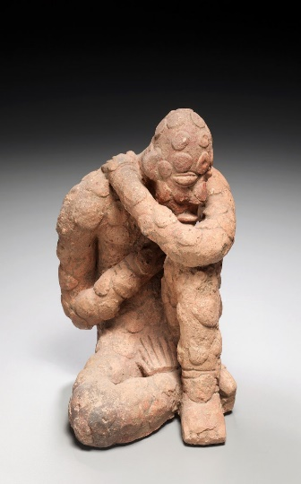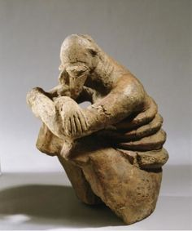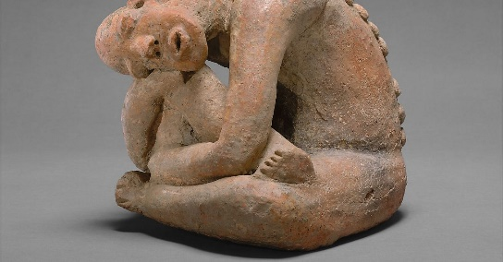
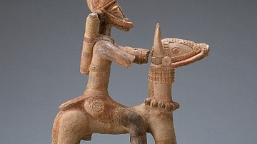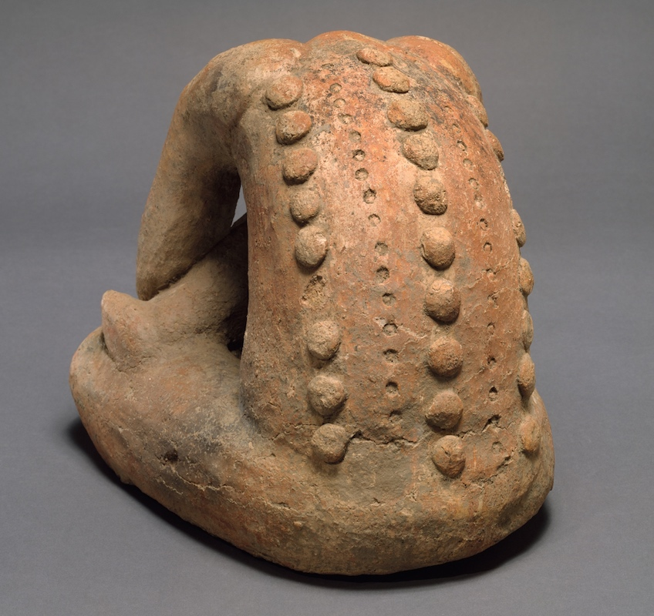

Word Count:1071

References
Breunig, Peter. "Africa and the Nok culture period." Nok: African Sculpture in Archaeological Context 33 (2014).
Brodie, Neil, Jenny Doole, and Peter Watson. "Stealing history." CRM-WASHINGTON- 25.2 (2002): 7-10.
Klesmith, Elizabeth A. "Nigeria and Mali: The case for repatriation and protection of cultural heritage in post-colonial Africa." Notre Dame J. Int'l & Comp. L. 4 (2013): 45.
MCINTOSH, RODERICK J. "EXCISING THE ROT OF CULTURAL GENOCIDE." Plundering Africa's Past (1996): 45.

